Irrigation & Weather Data Warehouse

This data warehouse stores hourly and daily weather data from the Open-Meteo API and computes automated irrigation decisions. The database is implemented in SQL Server and populated using a Python ETL pipeline built with SQLAlchemy.
The schema follows a star schema and is normalized to approximately Third Normal Form (3NF):
- Dimension tables store descriptive attributes
- Fact tables store measurable events
- All non-key attributes depend solely on the primary key
- Foreign keys enforce referential integrity
- No redundant or repeating groups

ER Diagram
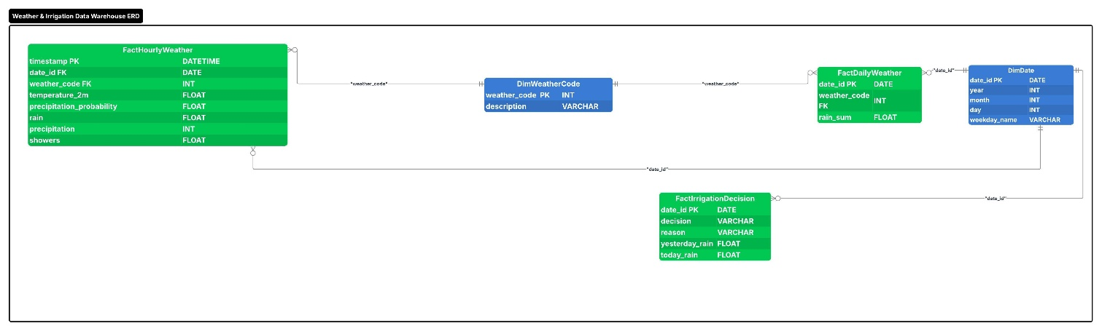

Database Overview
The database contains five tables:
- DimDate
- DimWeatherCode
- FactDailyWeather
- FactHourlyWeather
- FactIrrigationDecision
Entity Relationship Summary
Table | Purpose
DimDate | Stores calendar attributes for each date
DimWeatherCode | Stores Open-Meteo weather condition codes
FactDailyWeather | Stores daily aggregated weather metrics
FactHourlyWeather | Stores hourly weather observations
FactIrrigationDecision | Stores calculated irrigation decisions
Table Documentation
1. DimDate
Purpose
Calendar lookup table used by all fact tables. Supports grouping, filtering, and time-series analysis.
Primary Key
- date_id
Relationships
- One date → many daily weather records
- One date → many hourly weather records
- One date → many irrigation decisions
Table Structure
Column Name | Data Type | Key | Description
date_id | DATE | Primary Key | Unique date identifier
year | INT |  | Calendar year
month | INT |  | Calendar month
day | INT |  | Day of month
weekday_name | VARCHAR(20) |  | Name of weekday

2. DimWeatherCode - Preloaded
Purpose
Stores Open-Meteo weather condition codes and descriptions.
Primary Key
- weather_code
Relationships
- One weather code → many daily weather records
- One weather code → many hourly weather records
- One weather code → many irrigation decisions

Data-Quality Note
The ETL pipeline validates weather codes. Any invalid code causes the pipeline to stop, ensuring referential integrity.
Table Structure
Column Name | Data Type | Key | Description
weather_code | INT | Primary Key | Weather condition code
description | VARCHAR(100) |  | Human-readable description
IsActive | BIT |  | Indicates whether the code is currently used

3. FactDailyWeather
Purpose
Stores daily aggregated weather metrics from the Open-Meteo API. Derived from hourly observations
Primary Key
- date_id
Foreign Keys
- weather_code → DimWeatherCode.weather_code
Table Structure
Column Name | Data Type | Key | Description
date_id | DATE | Primary Key | Link to DimDate
weather_code | INT | Foreign Key | Dominant weather code for the day
rain_sum | FLOAT |  | Total rainfall for the day
et0 | FLOAT |  | Daily evapotranspiration estimate
avg_humidity | FLOAT |  | Average humidity for the day
4. FactHourlyWeather
Purpose
Stores hourly weather observations including temperature, humidity, precipitation, and weather codes.
Primary Key
- timestamp
Foreign Keys
- date_id → DimDate.date_id
- weather_code → DimWeatherCode.weather_code

Table Structure
Column Name | Data Type | Key | Description
timestamp | DATETIME | Primary Key | Hour of observation
date_id | DATE | Foreign Key | Link to DimDate
weather_code | INT | Foreign Key | Link to DimWeatherCode
temperature_2m | FLOAT |  | Temperature at 2m height
humidity | FLOAT |  | Relative humidity(%)
precipitation_probability | FLOAT |  | Chance of precipitation
rain | FLOAT |  | Rain amount(mm)
showers | FLOAT |  | Shower intensity

5. FactIrrigationDecision
Purpose
Stores calculated irrigation decisions based on rainfall, humidity, evapotranspiration and short term forecast conditions.
Primary Key
- date_id
Foreign Keys
- date_id → DimDate.date_id
- weather_code → DimWeatherCode.weather_code
Calculated Fields
- yesterday_rain
- today_rain
- next_6hr_rain
- avg_humidity
- et0
- decision
- reason
Table Structure
Column Name | Data Type | Key | Description
date_id | DATE | Primary Key | Link to DimDate
decision | VARCHAR(10) | Calculated | WATER or SKIP
reason | VARCHAR(255) | Calculated | Explanation for decision
yesterday_rain | FLOAT | Calculated | Rainfall from previous day
today_rain | FLOAT | Calculated | Rainfall today
next_6hr_rain | FLOAT | Calculated | Rain expected in next 6 hours
avg_humidity | FLOAT | Calculated | Daily average humidity
et0 | FLOAT | Calculated | Daily evapotranspiration
weather_code | INT | Foreign Key | Dominant weather code
Cardinality Relationships
Parent Table | Child Table | Relationship Type
DimDate | FactDailyWeather | One-to-Many
DimDate | FactHourlyWeather | One-to-Many
DimDate | FactIrrigationDecision | One-to-Many
DimWeatherCode | FactDailyWeather | One-to-Many
DimWeatherCode | FactHourlyWeather | One-to-Many
DimWeatherCode | FactIrrigationDecision | One-to-Many

